

Practices for Secure Software Report

Table of Contents
Document Revision History 3
Client 3
Instructions 3
Developer 4
1. Algorithm Cipher 4
2. Certificate Generation 4
3. Deploy Cipher 4
4. Secure Communications 4
5. Secondary Testing 4
6. Functional Testing 4
7. Summary 4
8. Industry Standard Best Practices 4

Document Revision History

Version | Date | Author | Comments
1.0 | 10/18/2026 | John Grzeskowiak | SNHU CS305

Client



Instructions

Submit this completed practices for secure software report. Replace the bracketed text with the relevant information. You must document your process for writing secure communications and refactoring code that complies with software security testing protocols.

- Respond to the steps outlined below and include your findings.
- Respond using your own words. You may also choose to include images or supporting materials. If you include them, make certain to insert them in all the relevant locations in the document.
- Refer to the Project Two Guidelines and Rubric for more detailed instructions about each section of the template.

Developer
John Grzeskowiak

Algorithm Cipher

I would recommend AES-256-GCM as the encryption algorithm cipher to protect our sensitive information because it provides us with confidentiality and integrity by encrypting data and detecting unauthorized modifications. AES-256-GCM uses a 256-bit encryption key and a 128-bit block size, also generating an authentication tag to detect tampering. AES-256-GCM uses the same key for encryption and decryption, so the key should be generated randomly and securely stored. Each encryption must use a nonce, a unique identifier that is used during encryption, to prevent vulnerabilities such as reverse engineering our key. Symmetric key encryption is what our algorithm will use where it’s a single key to encrypt or decrypt, but an asymmetric key works slightly different, where the encryption key is public, but the decryption key is kept private only for those who will need to decrypt the data. Encryption algorithms are constantly evolving, prior to AES, DES was the standard but was vulnerable to brute-force attacks because of the short length of key, as technology evolves so will our encryption standards.

Certificate Generation
Insert a screenshot below of the CER file.

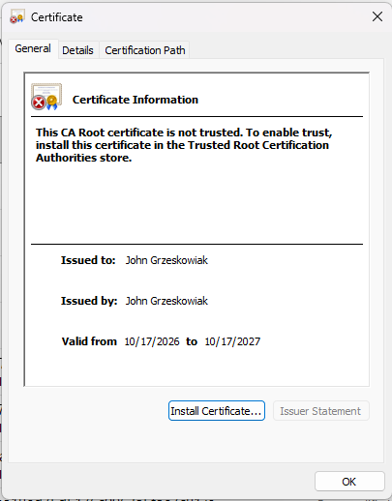

Deploy Cipher
Insert a screenshot below of the checksum verification.

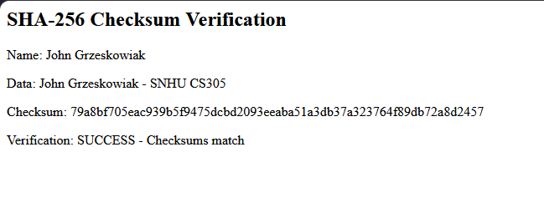

Secure Communications
Insert a screenshot below of the web browser that shows a secure webpage.

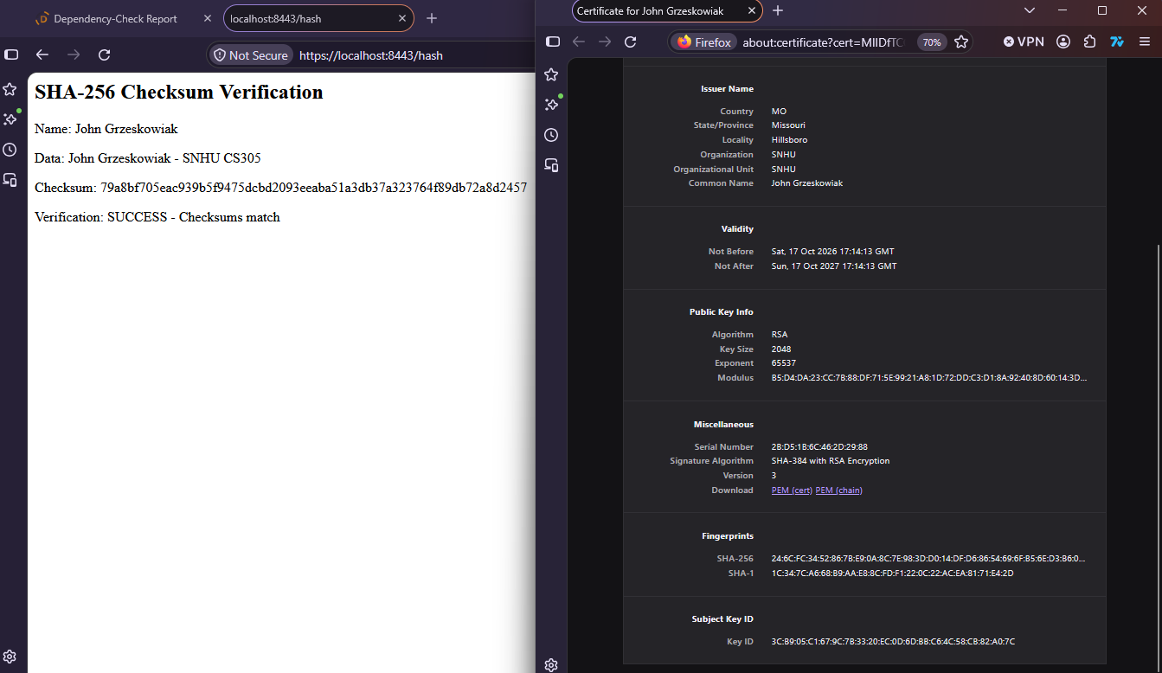

Secondary Testing
Insert screenshots below of the refactored code executed without errors and the dependency-check report.

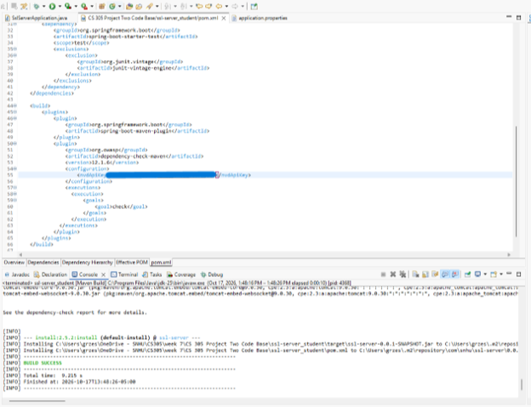
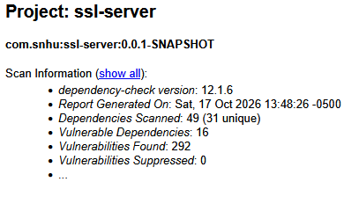

Functional Testing
Insert a screenshot below of the refactored code executed without errors.

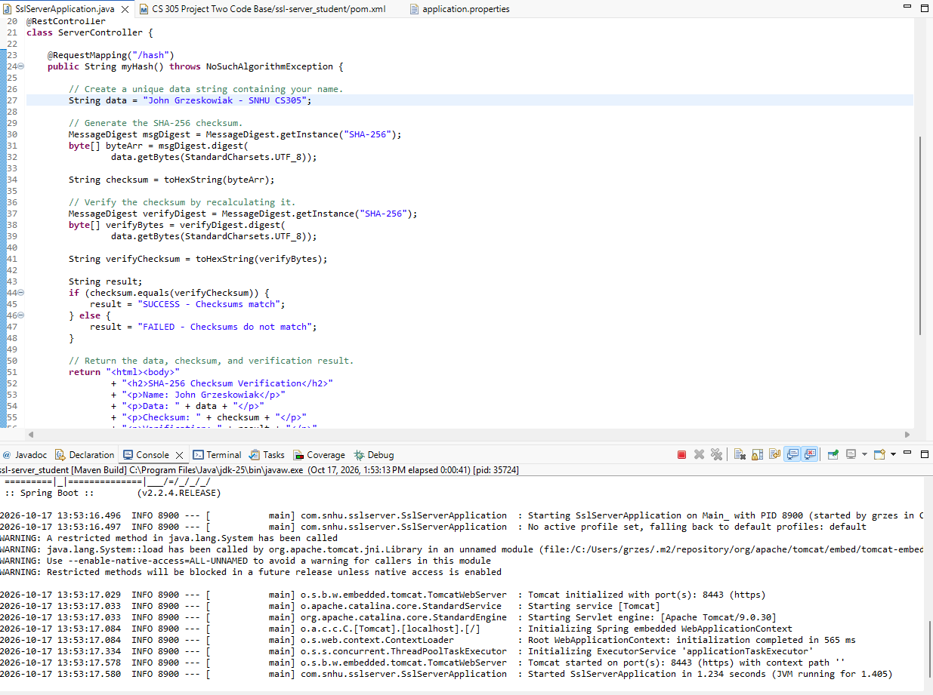

Summary

The code was refactored in several ways to improve security. To begin, we want to ensure our libraries and software are up to date and in a secure state. After running the vulnerability test, we can verify which vulnerabilities are worrisome and not just an out-of-date library, false positives or a vulnerability that can’t be exploited in our software. We then changed our HTTP to be HTTPS which uses TLS/SSL encryption rather than plain text. With the protocol change we also added a self-signed certificate to prove that communication is secure for the users. These simple, yet effective, layers of security help protect the users data. If new errors or vulnerabilities occur, we then must update and retest our code to fix said errors and vulnerabilities.

Industry Standard Best Practices

I applied industry standard secure coding practices by using strong encryption, secure communication and vulnerability tests to identify potential flaws. Using these practices allows us to ensure the application has high level security which in result reduces the risk of unauthorized access, data leaks, and several other harmful attacks. Consistently testing and updating dependencies are necessary to ensure newly discovered vulnerabilities aren’t active/ affecting our software. Following these security practices allows us to protect our sensitive data, while reducing the risk of security breaches maintaining our user’s trust increasing the company’s overall well-being.

